ASSIGNMENT-3

**YOUTUBE-API**

**Objective:**

To Create an application which displays the desired videos based on the keywords entered by the user in the search tab.

**Features of the application:**

This application consists of home page where users can enter their search words in the search tab. Based on the users input the desired YouTube videos are displayed. YouTube-API is used to display the videos based on the key word given by user. This application is made responsive.

**Steps of Execution:**

This screenshot shows the home page where user can search the videos.

A screenshot of a computer

Description generated with very high confidence

Desired videos on keyword “Data Driven Documents” are displayed.

A screenshot of a cell phone

Description generated with very high confidence

Videos on keyword “Java Programming” are shown in following screenshot.

A screenshot of a computer

Description generated with very high confidence

Videos on keyword “UMKC” are shown in following screenshot.

A screenshot of a computer screen

Description generated with very high confidence

On resizing the window, the content in the web page also responds to it. Following two screenshots shows the feature of responsive web design.

A screenshot of a person

Description generated with very high confidence

A screenshot of a social media post

Description generated with very high confidence

**Code Snippets:**

Following are code snippets of java script, app.js

A screenshot of a social media post

Description generated with very high confidence

A screenshot of a social media post

Description generated with very high confidence

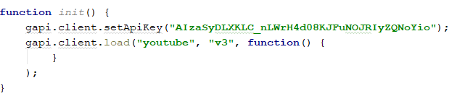

**TWITTER FRIENDS LIST**

**DATA DRIVEN VISUALIZATZION**

**Objective:**

Get the twitter friends list using twitter API and visualize them through D3.JS

**Features of the application:**

Viewed the twitter friends list using DATA DRIVEN VISUALIZATION (tree and map)

**Screenshots:**

A screenshot of a cell phone

Description generated with very high confidence

A screenshot of a computer

Description generated with very high confidence

**References:**

<https://github.com/d3/d3/wiki>

<https://developers.google.com/youtube/v3/code_samples/javascript>

<https://developers.google.com/youtube/v3/getting-started>

**Git-hub Link:**

https://github.com/Ravali2007/CS5590-490/wiki/Lab-3